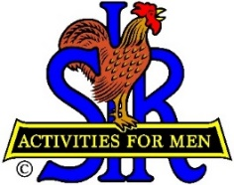

**SIR State Bowling Committee**

**Sir Dan Weller, Chairman**

925-935-5510 dweller@astound.net

SIR STATE BOWLING COMMITTEE

GENERAL MEETING (ZOOM)

**10:00 AM Saturday, April 5, 2025**

**AGENDA**

10:00 - OPENING REMARKS - Sir Dan Weller, Chairman

Flag Salute, Welcome, Review / Approve Agenda

10:10 - Chairman Notes – Sir Dan Weller, Chairman

10:30 - SECRETARY’S REPORT – Sir Gary Kaufmann, Secretary

Review / Approve Prior Meeting

10:40 - TREASURER’S REPORT – Sir Larry Mustain, Treasurer

Review / Approve Current Financial Report

10:50 - OPERATIONS ADVISOR– Sir Ray DiBasilio

Status of the Tournament Operations

11:20 - POLICY ADVISOR – OPEN

Status of the Bowling By-Laws and Rules,

11:25 - WEBSITE MANAGER – Sir Dan Weller

2025 SBTA Status

11:30 - Questions and Comments from the Participators

11:50 - OLD BUSINESS – Sir Dan Weller

Looking for Committee helpers

11:55 - CLOSING REMARKS – Sir Dan Weller

Next meeting (General Committee) – 10:00 AM Saturday July 12, 2025

12:00 - ADJOURN